**1.** **Create Application form using various text formats.**

**AIM:** To create a Registration Form using various text formats in HTML.

**ALGORITHM:**

**Step 1:** Open any Text Editor / IDE.

**Step 2:** HTML. Declare <html> tag and <head> and <body> tag within it.

**Step 3:** Within the <head> tag declare the <title> of your webpage.

**Step 4:** Within the <body> tag declare the form tag, within the form tag use input tag to get input from the user.

**Step 5:** Use Select tag to use the dropdown menu and use option tag within the Select tag to show Options.

**Step 6:** Use <textarea> to store address in Multiline.

**Step 7:** Declare an input tag to Submit the Submit Button.

**Step 8:** Close the form, body and html tag respectively.

**PROGRAM:**

<!DOCTYPE html>

<html lang="en">

<head>

<meta charset="utf-8">

<title>Application Form using various HTML Tags</title>

</head>

<body bgcolor="cyan">

<form>

<label>First Name</label>

<input type="text" name="first_name" id="first_name" size="20"> <br> <br>

<label>Middle Name</label>

<input type="text" name="last_name" id="last_name" size="20"> <br> <br>

<label>Last Name</label>

<input type="text" name="last_name" id="last_name" size="20"> <br> <br>

Course:

<label>

<select>

<option value="Course">Course</option>

<option value="BCA">BCA</option>

<option value="BBA">BBA</option>

<option value="B.Tech">B.Tech</option>

<option value="MBA">MBA</option>

<option value="MCA">MCA</option>

<option value="M.Tech">M.Tech</option>

</select>

</label>

<br>

<br>

<label>Gender:

</label> <br>

<input type="radio" name="gender" />Male <br>

<input type="radio" name="gender" />Female <br>

<input type="radio" name="gender" />Others<br><br>

<label>

Phone:

<input type="text" name="phone" value="+91" size="1" maxlength="3" />

<input type="text" name="phone" size="10"> <br> <br>

Address:

<br>

<textarea cols="90" rows="10" value="address"></textarea> <br> <br>

Email:

<input type="email" name="email" size="30" /> <br> <br>

Password:

<input type="password" name="password" /> <br> <br>

Re-type Password:

<input type="password" name="password" /> <br> <br>

<input type="submit" value="Submit" />

</label>

</form>

</body>

</html>

**OUTPUT:**

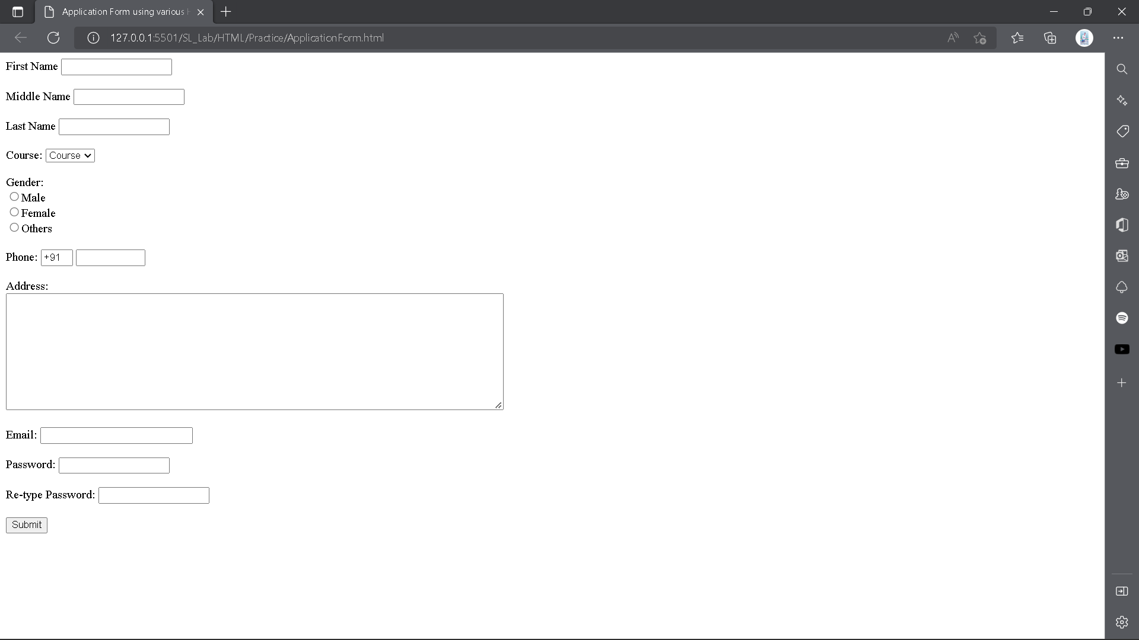

**RESULT:** Thus, the above webpage for registration form is created successfully.

**2. Create VINAYAKA MISSIONS RESEARCH FOUNDATION website using HTML tags**

**AIM:** To create the VMRF website using frame tag in HTML.

**ALGORITHM:**

**Step 1:** Open any Text Editor / IDE.

**Step 2:** Create some HTML files like (index.html, about.html, contact.html, home.html etc).

**Step 3:** Divide the frameset tags into the webpage to preview different webpages in particular area of the webpage.

**Step 4:** Code each page with the required contents & link each pages to each other.

**Step 5:** Save all the files in a folder & run index.html file as the main page.

**Step 6:** Run the index.html file using Live Server.

**PROGRAM:**

**index.html**

**<!DOCTYPE html>**

**<html lang="en">**

<head>

<meta charset="utf-8">

<title>VMRF</title>

</head>

<frameset rows="20%,*">

<frame name="logo" target="main" noresize="noresize" scrolling="no" src="logo.html" />

<frameset cols="10%,*">

<frame name="links" target="main" noresize="noresize" scrolling="no" src="links.html" />

<frame name="content" src="home.html" target="main" noresize="noresize" scrolling="auto" />

</frameset>

</frameset>

</html>

**about.html**

<!DOCTYPE *html*>

<html *lang*="en">

<head>

    <meta *charset*="utf-8">

    <title>About VMRF</title>

</head>

<body>

    <h1 align="center">University Profile</h1>

    <p>Vinayaka Missions had its inception in the year 1981 with the establishment of the Thirumuruga Kirupananda Variyar Thavathiru Sundara Swamigal (TKVTSS) Medical Educational and Charitable Trust. Not far from then, in 1982, the Founder-Chairman,

        Dr. A Shanmugasundaram instituted the Vinayaka Mission's College of Pharmacy in Salem, the pioneer institution of Vinayaka Missions. In the year 2001 the "Deemed to be University" status was conferred on Vinayaka Missions by The Ministry of Human Resources Development, Government of India, with the recommendations of the UGC Under Section 3 of the UGC Act, 1956 as an acknowledgement of its excellence, satisfaction of the highest level of academic standards and best infrastructural facilities provided to achieve preeminence in education and by virtue of this recognition Vinayaka Missions trascended to becoming Vinayaka Missions Research Foundation (VMRF) as the 48th University in India.</p>

        <h1 align="center">Our Journey</h1>

        <p><strong>1981<br>TKVTSS<br></strong>

            Vinayaka Missions had its inception in the year 1981 with the establishment of the Thirumuruga Kirupananda Variyar Thavathiru Sundara Swamigal (TKVTSS) Medical Educational and Charitable Trust.</p>

        <p><strong>1982<br>Vinayaka Missions College of Pharmacy<br></strong>

            Dr. A Shanmugasundaram instituted the Vinayaka Missions College of Pharmacy in Salem, the pioneer institution of Vinayaka Missions.</p>

        <p><strong>2001<br>University" status<br></strong>

            In the year 2001 the "University" status was conferred on Vinayaka Missions by The Ministry of Human Resources Development, Government of India, with the recommendations of the UGC (Established Under Section 3 of the UGC Act, 1956) as an acknowledgement of its excellence, satisfaction of the highest level of academic standards and best infrastructural facilities provided to achieve preeminence in education and by virtue of this recognition Vinayaka Missions trascended to becoming Vinayaka Missions Research Foundation (VMRF) as the 48th University in India.</p>

</body>

</html>

**links.html**

<!DOCTYPE html>

<html lang="en">

<head>

<title>Links of VMRF</title>

</head>

<body>

<ul>

<li><a href="home.html" target="content" > Home</a></li>

<li><a href="about.html" target="content">About Us</a></li>

<li>Academics

<ul>

<li><a href="faculty.html" target="content">Faculties</a></li>

<li><a href="event.html" target="content">Events</a></li>

</ul>

</li>

<li><a href="contact.html" target="content">Contact Us</a></li>

</ul>

</body>

</html>

**home.html**

<!DOCTYPE html>

<html lang="en">

<head>

<meta charset="utf-8">

<title>Home - VMRF </title>

</head>

<body>

<h1 align="center">WELCOME TO VINAYAKA MISSION'S RESEARCH FOUNDATION (Deemed To Be University)</h1>

<p><strong>Vinayaka Missions Research Foundation (VMRF) is a pioneering and vibrant university offering a multi-cultural experience with an ambience marked by the perfect harmony of living in diversity. The university is committed to offering education in the most professional manner and one that ensures enormous growth potential to the students. One of the biggest universities in India, VMRF boasts of the most diversified education in terms of the number of faculties, ranging from medicine, paramedicine, engineering and technology to management - almost the entire gamut of academic disciplines. The University main campus in Salem is truly a scenic marvel surrounded by mountains and a hallmark of the city.</strong></p>

<h1 align="center">OUR CAMPUS</h1>

<img src="../VMRF/Images/Campus.png" alt="VMRF Campus">

<h1 align="center">ACADEMIC EVENTS</h1>

<img src="../VMRF/Images/Events.png" alt="EVENTS">

</body>

</html>

**logo.html**

<!DOCTYPE html>

<html lang="en">

<head>

<meta charset="utf-8">

<title>Logo of VMRF</title>

</head>

<body>

<img src="Images/Logo.png" alt="VMRF Logo">

</body>

</html>

**faculty.html**

<!DOCTYPE html>

<html lang="en">

<head>

<meta charset="utf-8">

<title>Faculty of VMRF</title>

</head>

<body>

<h1>Faculties of Various Departments</h1>

<img src="../VMRF/Images/Faculties.png" alt="Faculties">

</body>

</html>

**event.html**

<!DOCTYPE html>

<html lang="en">

<head>

<meta charset="utf-8">

<title>Events of VMRF</title>

</head>

<body>

<h1>Academics Event</h1>

<ul>

<li>VMACON, Salem - Academic Events Conducted - July - 2022</li>

<li>AVIT- Productive Tools in AutoCAD</li>

<li>VMACON, Salem - Academic Events Conducted - June 2022</li>

<li>VMACON, Salem - Academic Events - April 2022</li>

<li>VMACON, Salem - Academic Events Conducted - March 2022</li>

<li>VMHMC - Academic activities - March 2022</li>

<li>VMACON, Salem - Academic Events Conducted - February 2022</li>

<li>VMHMC - Academic activities - Feb 2022</li>

<li>VMACON, Salem - Academic Events Conducted - November 2021</li>

<li>VMACON, Salem - Academic Events Conducted - October 2021</li>

<li>VMACON, Salem - Academic Events Conducted - September 2021</li>

<li>SAHS, Salem - Industry Designed Course -Optometry Report (2020 - 2021)</li>

<li>SAHS, Salem - Siemens healtineers offered - Industry specific designed course report (2020 - 2021)</li>

<li>VMACON, Salem - Academic Events Conducted - July 2021</li>

<li>VMACON, SALEM - CHILD LABOUR DAY– 2021</li>

<li>VMACON, SALEM - INTERNATIONAL MIDWIVES DAY</li>

<li>VMACON, Salem - ONLINE GUEST LECTURE (GL)</li>

<li>WORLD OPTOMETRY DAY CELEBRATION REPORT 2021, SCHOOL OF ALLIED HEALTH SCIENCES, SALEM</li>

<li>VMACON - ACADEMIC EVENTS - MARCH - 2021</li>

<li>VMHMCH, Salem has awarded NABH Accreditation</li>

<li>CME Program on "The Pros and Cons of clinical tips" VMHMCH on 22-12-2020</li>

<li>STUDENT INDUCTION PROGRAMME - SAHS,SALEM</li>

<li>VMRF DU Conducted 13th Convocation Virtually on 07-07-2020 by 11.00am</li>

<li>SAHS, Salem WORLD INTELLECTUAL PROPERTY RIGHTS DAY</li>

<li>VMKVEC NCC Activities in month of April 2020</li>

<li>VMRF DU Organized FDP on NAAC - Revised Assessment and Accreditation Frame Work</li>

<li>first Annual Endowement oration 2020 by Padmasree Dr M R Rajgopal Chairman Pallium India at AVMC Puducherry

on 29 01 2020</li>

</ul>

</body>

</html>

**contact.html**

<!DOCTYPE html>

<html lang="en">

<head>

<meta charset="utf-8">

<title>Events of VMRF</title>

</head>

<body>

<h1>Academics Event</h1>

<ul>

<li>VMACON, Salem - Academic Events Conducted - July - 2022</li>

<li>AVIT- Productive Tools in AutoCAD</li>

<li>VMACON, Salem - Academic Events Conducted - June 2022</li>

<li>VMACON, Salem - Academic Events - April 2022</li>

<li>VMACON, Salem - Academic Events Conducted - March 2022</li>

<li>VMHMC - Academic activities - March 2022</li>

<li>VMACON, Salem - Academic Events Conducted - February 2022</li>

<li>VMHMC - Academic activities - Feb 2022</li>

<li>VMACON, Salem - Academic Events Conducted - November 2021</li>

<li>VMACON, Salem - Academic Events Conducted - October 2021</li>

<li>VMACON, Salem - Academic Events Conducted - September 2021</li>

<li>SAHS, Salem - Industry Designed Course -Optometry Report (2020 - 2021)</li>

<li>SAHS, Salem - Siemens healtineers offered - Industry specific designed course report (2020 - 2021)</li>

<li>VMACON, Salem - Academic Events Conducted - July 2021</li>

<li>VMACON, SALEM - CHILD LABOUR DAY– 2021</li>

<li>VMACON, SALEM - INTERNATIONAL MIDWIVES DAY</li>

<li>VMACON, Salem - ONLINE GUEST LECTURE (GL)</li>

<li>WORLD OPTOMETRY DAY CELEBRATION REPORT 2021, SCHOOL OF ALLIED HEALTH SCIENCES, SALEM</li>

<li>VMACON - ACADEMIC EVENTS - MARCH - 2021</li>

<li>VMHMCH, Salem has awarded NABH Accreditation</li>

<li>CME Program on "The Pros and Cons of clinical tips" VMHMCH on 22-12-2020</li>

<li>STUDENT INDUCTION PROGRAMME - SAHS,SALEM</li>

<li>VMRF DU Conducted 13th Convocation Virtually on 07-07-2020 by 11.00am</li>

<li>SAHS, Salem WORLD INTELLECTUAL PROPERTY RIGHTS DAY</li>

<li>VMKVEC NCC Activities in month of April 2020</li>

<li>VMRF DU Organized FDP on NAAC - Revised Assessment and Accreditation Frame Work</li>

<li>first Annual Endowement oration 2020 by Padmasree Dr M R Rajgopal Chairman Pallium India at AVMC Puducherry

on 29 01 2020</li>

</ul>

</body>

</html>

**OUTPUT:**

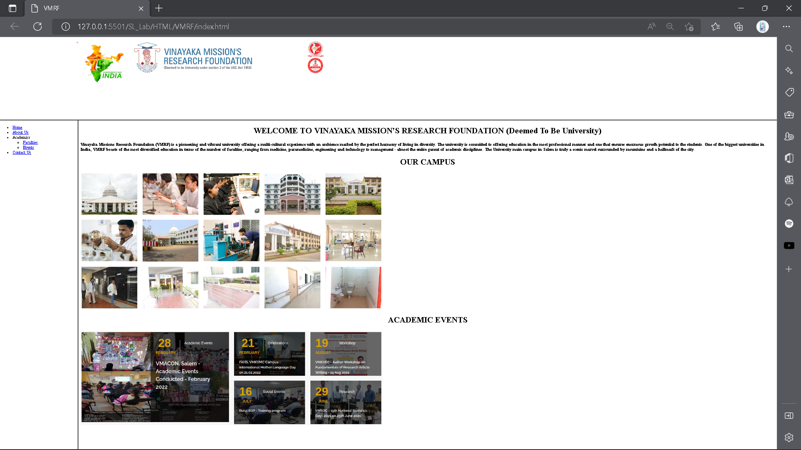

**RESULT:** Thus, The above webpage of VMRF is successfully created.

**3. Create a table using HTML.**

**AIM:** To create a Store Bill using Table in HTML.

**ALGORITHM:**

**Step 1:** Open any Text Editor / IDE.

**Step 2:** Declare the HTML Tag.

**Step 3:** Within the HTML Tag, Declare the head & body tag.

**Step 4:** Within the head tag declare the title.

**Step 5:** Declare the table using <table> tag.

**Step 6:** Within the table tag declare heading using <tr> tag and <th> tag defines the head of the table and content using <td> tag.

**Step 7:** Finally Close the html tag.

**Step 8:** Run the html file using Live Server.

**PROGRAM:**

<table border="1">

<caption> A Complex Table</caption>

<thead>

<tr>

<th colspan="3">Imvoice #123456789</th>

<th>14 January 2025</th>

</tr>

<tr>

<td colspan="2">

<strong>Pay to: </strong>

<br>Acme Billing Co.

<br>123 Main St.

<br>Cityville, NA 12345

</td>

<td colspan="2">

<strong>Customer: </strong>

<br> John Smith

<br> 321 Willow Way

<br> Southeast Northwestshire, NA 54321

</td>

</tr>

</thead>

<tbody>

<tr>

<th>Name / Description</th>

<th>Qty.</th>

<th>@</th>

<th>Cost</th>

</tr>

<tr>

<td>Staples (Box)</td>

<td>100</td>

<td>1.00</td>

<td>100.00</td>

</tr>

<tr>

<td>Paperclips</td>

<td>1000</td>

<td>0.01</td>

<td>10.00</td>

</tr>

</tbody>

<tfoot>

<tr>

<th colspan="3"> Subtotal</th>

<td>110.00</td>

</tr>

<tr>

<th colspan="2">Tax</th>

<td>8%</td>

<td>8.80</td>

</tr>

<th colspan="3">Grand Total</th>

<td>$118.80</td>

</tfoot>

</table>

**OUTPUT:**

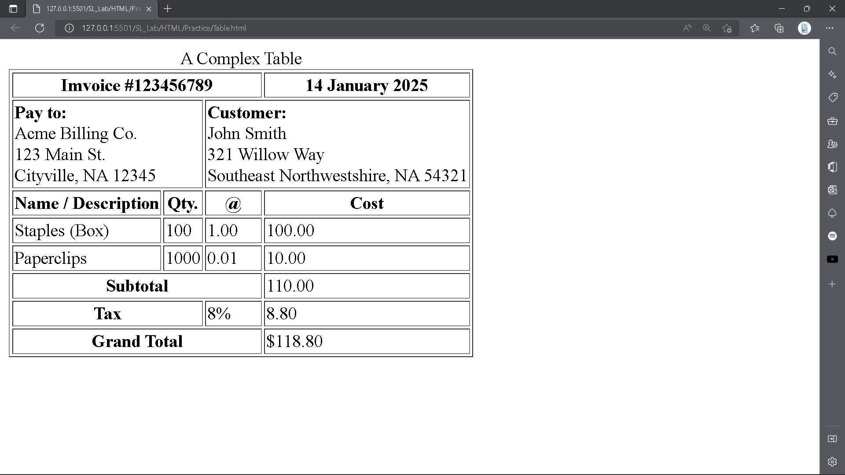

**RESULT:** Thus, The above webpage for creating the Store Bill is created successfully.

**4. Display your information using form controls.**

**AIM:** To display Personal Information using Form Controls.

**ALGORITHM:**

**Step 1:** Open any Text Editor / IDE.

**Step 2:** Within the HTML tag declare the head and body tag.

**Step 3:** Within the head tag declare the title using <title> tag.

**Step 4:** Declare a form tag and use input tag to get input from the user.

**Step 5:** Use<textarea> to store address in multi-line.

**Step 6:** Create a Submit button.

**Step 7:** Close the form & html tag respectively.

**Step 8:**  Run the HTML file using Live Server.

**PROGRAM:**

<!DOCTYPE html>

<html lang="en">

<head>

<meta charset="UTF-8">

<meta http-equiv="X-UA-Compatible" content="IE=edge">

<meta name="viewport" content="width=device-width, initial-scale=1.0">

<title>Personal Information</title>

</head>

<body>

<form action="">

<label for="name">Name:</label>

<input type="text" id="name"> <br> <br>

<label for="doB">D.O.B: </label>

<input type="date" id="doB"> <br> <br>

<label for="age">Age:</label>

<input type="number"> <br> <br>

<label for="sex">Sex: </label> <br>

<input type="radio" name="sex"> Male <br>

<input type="radio" name="sex"> Female <br>

<input type="radio" name="sex"> Others <br> <br>

<label for="fatherName">Father's Name:</label>

<input type="text" id="fatherName"> <br> <br>

<label for="motherName">Mother's Name:</label>

<input type="text" id="motherName"><br> <br>

<label for="occup">Father's Occupation: </label>

<input type="text" id="occup"> <br><br>

<label for="commuAddress">Communication Address: </label> <br>

<textarea name="comAdd" id="comAdd" cols="90" rows="10"></textarea> <br><br>

<label for="contact">Contact:</label>

<input type="text" id="contact"> <br><br>

<label for="qualification">Qualification: </label> <br>

<input type="checkbox">SSLS <br>

<input type="checkbox">HSC <br>

<input type="checkbox">UG <br>

<input type="checkbox">PG <br><br>

<label for="hobb">Hobbies</label> <br>

<input type="checkbox">Cricket <br>

<input type="checkbox">Football <br>

<input type="checkbox">Hockey <br>

<input type="submit" value="Submit"> <br>

</form>

</body>

</html>

**OUTPUT:**

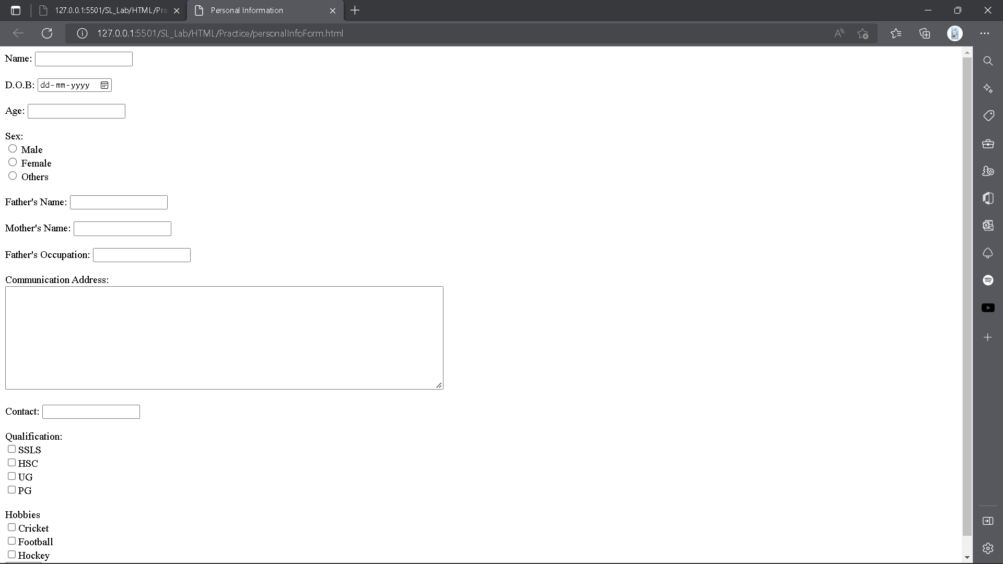

**RESULT:** Thus, the above website to display Personal Information is created successfully.

**5. Create style sheets with the style elements.**

**AIM:** To create a website to display about yourself using HTML Tags and CSS Properties and Selectors.

**ALGORITHM:**

**Step 1:** Open any Text Editor / IDE.

**Step 2:** Within the HTML Tag, Declare head and body tag.

**Step 3:** Within the body tag declare the div tag with class name container.

**Step 4:** Within div tag, Declare three div tags with class name and id.

**Step 5:** Put the content within this using h1 & p tag.

**Step 6:** Within the head tag, Declare a link tag to import .css file.

**Step 7:** Create a CSS file with the same name that we used in the link tag.

**Step 8:** Now start declaring the css properties using different selectors.

**Step 9:** Use properties like display, background, margin, padding, etc

**Step 10:** Save the HTML file with .html extension and CSS file with .css extension.

**Step 11:** Run the HTML file using Live Server.

**PROGRAM:**

<!DOCTYPE html>

<html lang="en">

<head>

<meta charset="utf-8">

<title>Cascading Style Sheets</title>

<link rel="stylesheet" href="/SL_Lab/CSS/casCading.css"> <!-- Using External Style Sheet -->

</head>

<body>

<div class="container">

<div class="sub-container" id="mySelf">

<h1>MySelf</h1>

<p>Hey, My name is Md Saddam Hussain. I'm from Bihar & currently staying in Chennai - Tamilnadu. I'm

Pursuing My UG Degree BCA from <span>School of Arts and Science - (VMRF)</span></p>

</div>

<div class="sub-container" id="myFamily">

<h1>My Family</h1>

<p>There are 3 members in My Family.</p>

<p>Me, My Mother & My lil Brother</p>

</div>

<div class="sub-container" id="friends">

<h1>FriendShip</h1>

<p><span>“Friendship is the hardest thing in the world to explain. It’s not something you learn in school.

But if you haven’t learned the meaning of friendship, you really haven’t learned

anything.”</span></p>

<p><span>“The most beautiful discovery true friends make is that they can grow

separately without growing apart.”</span></p>

<p>My Turu <strike>Lobe</strike> Friend - Tabish Hussain</p>

</div>

</div>

</body>

</html>

**casCading.css**

* {

margin: 0;

padding: 0;

}

body {

background: linear-gradient(rgb(129, 35, 35), rgb(109, 39, 239));

}

.container {

display: flex;

align-items: center;

justify-content: center;

height: 100vh;

width: 100%;

}

.sub-container {

border: 2px solid black;

margin: 10px;

padding: 10px;

height: 30%;

width: 30%;

}

#mySelf {

background-color: rgb(168, 151, 134);

border-radius: 80px;

height: fit-content;

}

#myFamily {

background-color: rgb(50, 139, 98);

border-radius: 80px;

height: fit-content;

}

#friends {

background-color: rgb(9, 255, 255);

border-radius: 60px;

height: fit-content;

}

h1,

p {

text-align: center;

font-weight: 5px;

}

span {

text-decoration: underline;

font-weight: bold;

}

p {

line-height: 1.5em;

font-size: 18px;

}

**OUTPUT:**

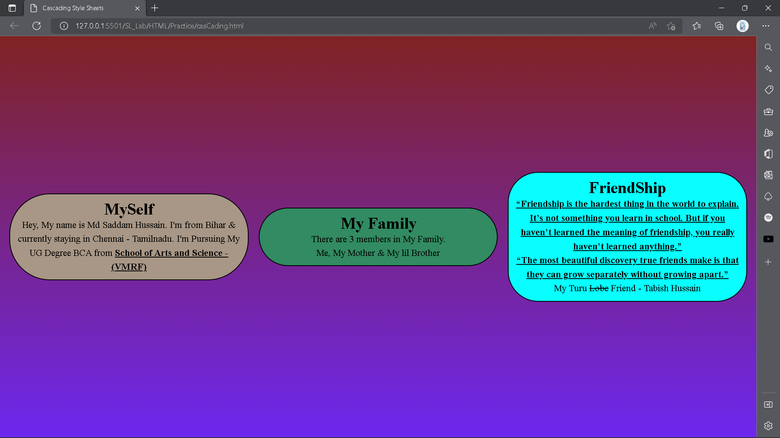

**RESULT:** Thus, the above webpage for displaying about yourself is created successfully.

**6 Create a Calculator format using JavaScript**

**AIM: To create a Calculator using HTML, CSS and JavaScript.**

**ALGORITHM:**

**Step 1: Open any Text Editor or IDE.**

**Step 2: Create four different files “index.html”, “style.css”, “utils.css”, “script.js” respectively.**

**Step 3: Link the other three files with “index.html” file.**

**Step 4: In the HTML file declare the number of buttons like the Calculator.**

**Step 5. Style as your imagination in the “style.css” and “utils.css” respectively.**

**Step 6: Write the JavaScript logic to make the Calculator work.**

**Step 7: Save all the files in a folder and execute the “index.html” file.**

**Step 8: Run the HTML file using Live Server extension (in VS Code only).**

**PROGRAM:  
index.html**  
<!DOCTYPE html>  
<html lang = "en">  
<head>  
<title> JavaScript Calculator </title>  
  
<style>  
h1 {  
 text-align: center;  
 padding: 23px;  
 background-color: skyblue;  
 color: white;  
 }  
  
#clear{  
width: 270px;  
border: 3px solid gray;  
 border-radius: 3px;  
 padding: 20px;  
 background-color: red;  
}  
  
.formstyle  
{  
width: 300px;  
height: 530px;  
margin: auto;  
border: 3px solid skyblue;  
border-radius: 5px;  
padding: 20px;  
}  
  
  
  
input  
{  
width: 20px;  
background-color: green;  
color: white;  
border: 3px solid gray;  
 border-radius: 5px;  
 padding: 26px;  
 margin: 5px;  
 font-size: 15px;  
}  
  
  
#calc{  
width: 250px;  
border: 5px solid black;  
 border-radius: 3px;  
 padding: 20px;  
 margin: auto;  
}  
  
</style>  
  
</head>  
<body>  
<h1> Calculator Program in JavaScript </h1>  
<div class= "formstyle">  
<form name = "form1">  
   
 <!-- This input box shows the button pressed by the user in calculator. -->  
 <input id = "calc" type ="text" name = "answer"> <br> <br>  
 <!-- Display the calculator button on the screen. -->  
 <!-- onclick() function display the number prsses by the user. -->  
 <input type = "button" value = "1" onclick = "form1.answer.value += '1' ">  
 <input type = "button" value = "2" onclick = "form1.answer.value += '2' ">  
 <input type = "button" value = "3" onclick = "form1.answer.value += '3' ">  
 <input type = "button" value = "+" onclick = "form1.answer.value += '+' ">  
 <br> <br>  
   
 <input type = "button" value = "4" onclick = "form1.answer.value += '4' ">  
 <input type = "button" value = "5" onclick = "form1.answer.value += '5' ">  
 <input type = "button" value = "6" onclick = "form1.answer.value += '6' ">  
 <input type = "button" value = "-" onclick = "form1.answer.value += '-' ">  
 <br> <br>  
   
 <input type = "button" value = "7" onclick = "form1.answer.value += '7' ">  
 <input type = "button" value = "8" onclick = "form1.answer.value += '8' ">  
 <input type = "button" value = "9" onclick = "form1.answer.value += '9' ">  
 <input type = "button" value = "*" onclick = "form1.answer.value += '*' ">  
 <br> <br>  
   
   
 <input type = "button" value = "/" onclick = "form1.answer.value += '/' ">  
 <input type = "button" value = "0" onclick = "form1.answer.value += '0' ">  
 <input type = "button" value = "." onclick = "form1.answer.value += '.' ">  
 <!-- When we click on the '=' button, the onclick() shows the sum results on the calculator screen. -->  
 <input type = "button" value = "=" onclick = "form1.answer.value = eval(form1.answer.value) ">  
 <br>   
 <!-- Display the Cancel button and erase all data entered by the user. -->  
 <input type = "button" value = "Clear All" onclick = "form1.answer.value = ' ' " id= "clear" >  
 <br>   
   
</form>  
</div>  
</body>  
</html>  
  
**OUTPUT:**

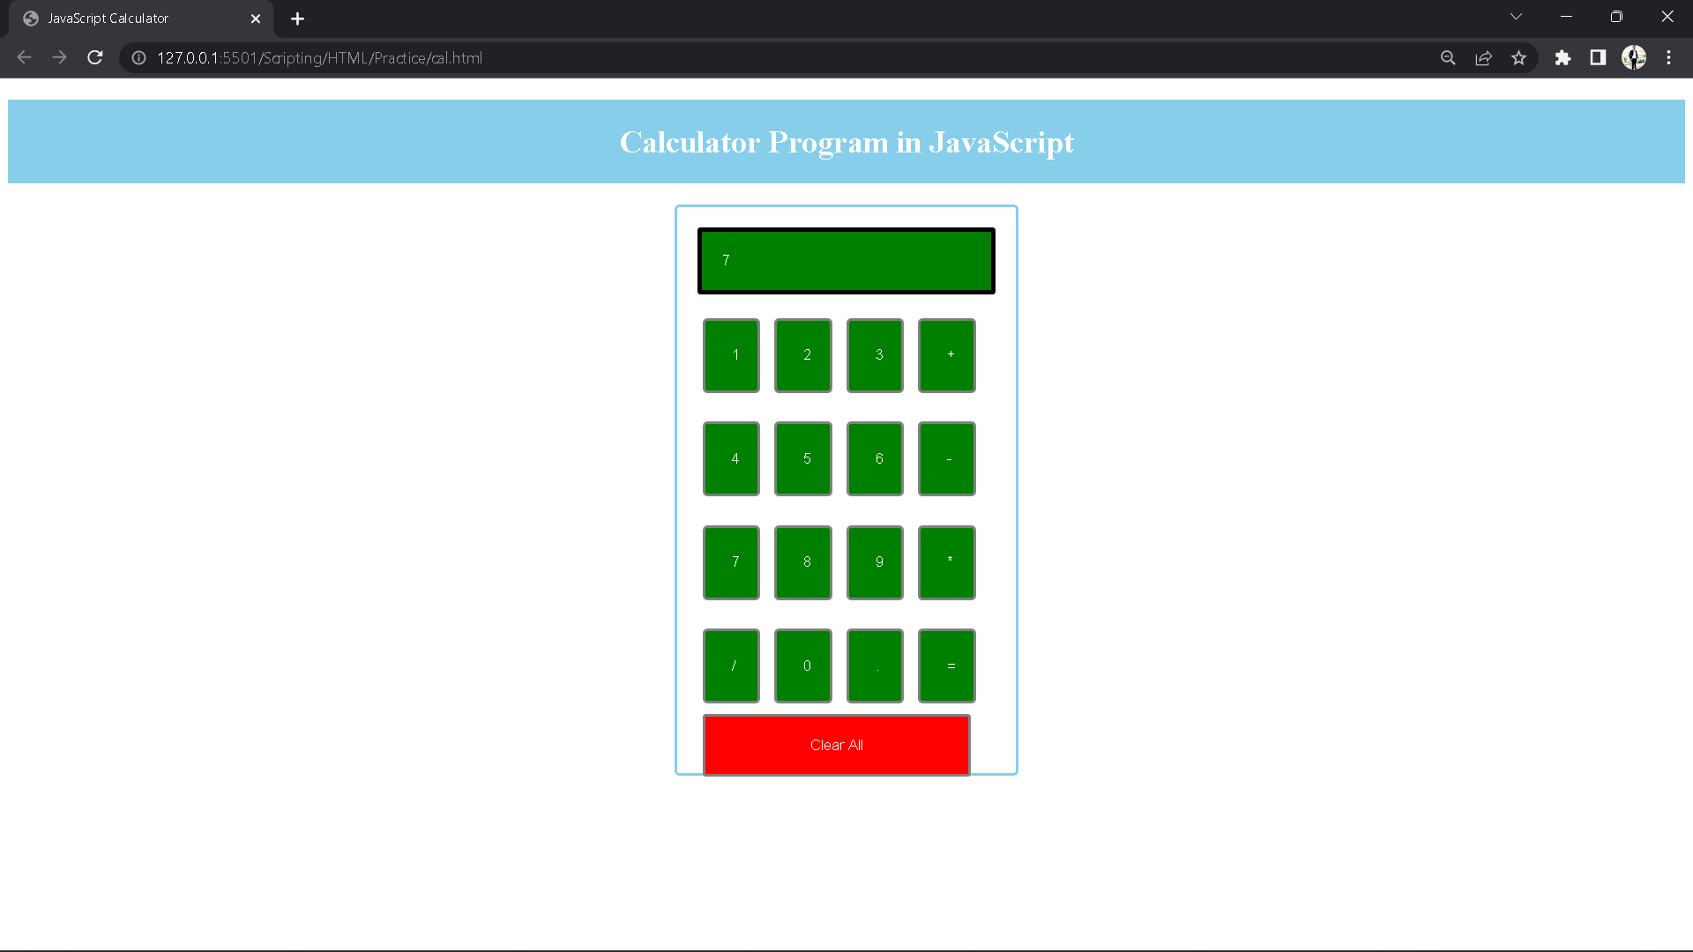

**RESULT: Thus, the above program for creating a Calculator using HTML, CSS and JavaScript is created and executed Successfully.**

**7. Create an array of 10 numbers and sort them using JavaScript.**

**ALGORITHM:**

**Step 1: Open any Text Editor / IDE.**

**Step 2: Declare HTML Tag along with it declare Head and Body Tag also.**

**Step 3: Create a JavaScript file by saving it with .js extension.**

**Step 4: Import the .js file to the HTML file using “script:src” (in VS Code).**

**Step 5: Within the JS file declare the function ‘sortArray’.**

**Step 6: Declare some other variables using let keyword.**

**Step 7: Use if condition to check the consecutive values of array and change it according to the condition.**

**Step 8: Display the output using ‘document.write()’ function.**

**Step 9: Close all the HTML Tags and save the file using .html extension.**

**Step 10: Run the HTML file using Live Server (VS Code Extension).**

**PORGRAM:**

**sortArray.html**

<!DOCTYPE html>

<html lang="en">

<head>

<meta charset="UTF-8">

<meta http-equiv="X-UA-Compatible" content="IE=edge">

<meta name="viewport" content="width=device-width, initial-scale=1.0">

<title>Sort Array in JavaScript</title>

<script src="/Scripting/JavaScript/sortArray.js"></script>

</head>

<body>

</body>

</html>

**sortArray.js**

function sortArray(arr, size) {

let i, j, val;

for (i = 0; i < size - 1; i++) {

j = i + 1;

while (j < size) {

if (arr[i] > arr[j]) {

val = arr[i];

arr[i] = arr[j];

arr[j] = val;

}

j++;

}

}

}

function printArray(arr) {

for (i = 0; i < arr.length; i++) {

document.write(arr[i] + " ");

}

}

let arr = [2, 1, 7, 3, 9, 4, 6, 5, 0, 8];

document.write("Before Sort: ");

printArray(arr);

document.write("</br>");

sortArray(arr, arr.length);

document.write("After Sort: ");

printArray(arr);

**OUTPUT:**

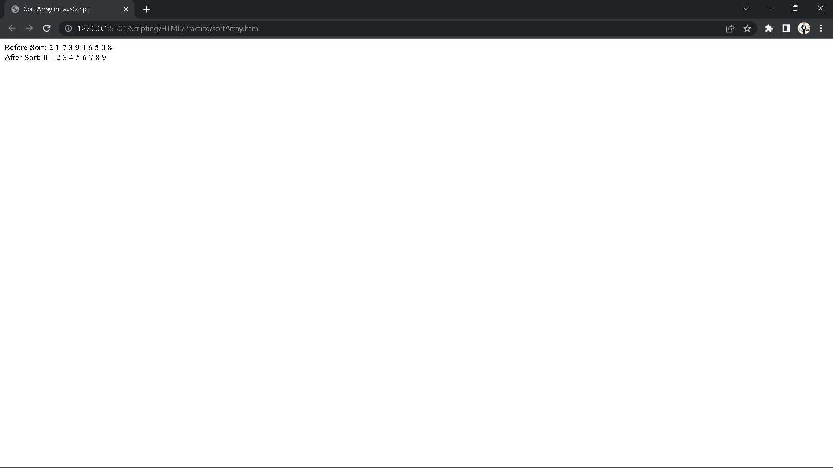

**RESULT:** Thus, the above webpage for sorting array in ascending order is created successfully.

**8 String manipulation using string object.**

**AIM: To write a JavaScript Program to perform String manipulation using different String methods.**

**ALGORITHM:**

**Step 1: Open any Text Editor or IDE.**

**Step 2: Declare the HTML tag along with the head and body tag.**

**Step 3: Create a JavaScript file using .js extension.**

**Step 4: Within the JS file declare a string “str”.**

**Step 5: Perform the various string manipulation using different string functions.**

**Step 6: Display the output using “document.write()” function.**

**Step 7: Close all the HTML tags and save the file using .html extension.**

**Step 8: Run the HTML file using Live Server Extension (in VS Code only).**

**PROGRAM:**

**index.html**

**<!DOCTYPE html>**

**<html lang="en">**

**<head>**

**<meta charset="UTF-8">**

**<meta http-equiv="X-UA-Compatible" content="IE=edge">**

**<meta name="viewport" content="width=device-width, initial-scale=1.0">**

**<title>String Manipulation</title>**

**<script src="/Scripting/JavaScript/stringMethods.js"></script>**

**</head>**

**<body>**

**</body>**

**</html>**

**script.js**

**let str = "JavaScript";**

**document.write(str.charAt(6));**

**document.write("<br>");**

**let str1 = "Good ";**

**let str2 = "Morning";**

**let str3 = str1 + str2;**

**document.write(str3 + " Saddam");**

**document.write("<br>");**

**let res = "This is a JavaScipt Program.";**

**document.write(res.lastIndexOf("is"));**

**document.write("<br>");**

**let rep = "This is the String Manipulation Program in JavaScript.";**

**document.write(rep.replace("the", "a"));**

**document.write("<br>");**

**let srch = "I'm Coding this in Morning 6AM";**

**document.write(srch.search("Morning"));**

**document.write("<br>");**

**let slc = "Today is Wednesday!";**

**document.write(slc.slice(5, 8));**

**document.write("<br>");**

**let spt = "I am finishing My Coding.";**

**const myArray = spt.split(" ");**

**document.write(myArray);**

**OUTPUT:**

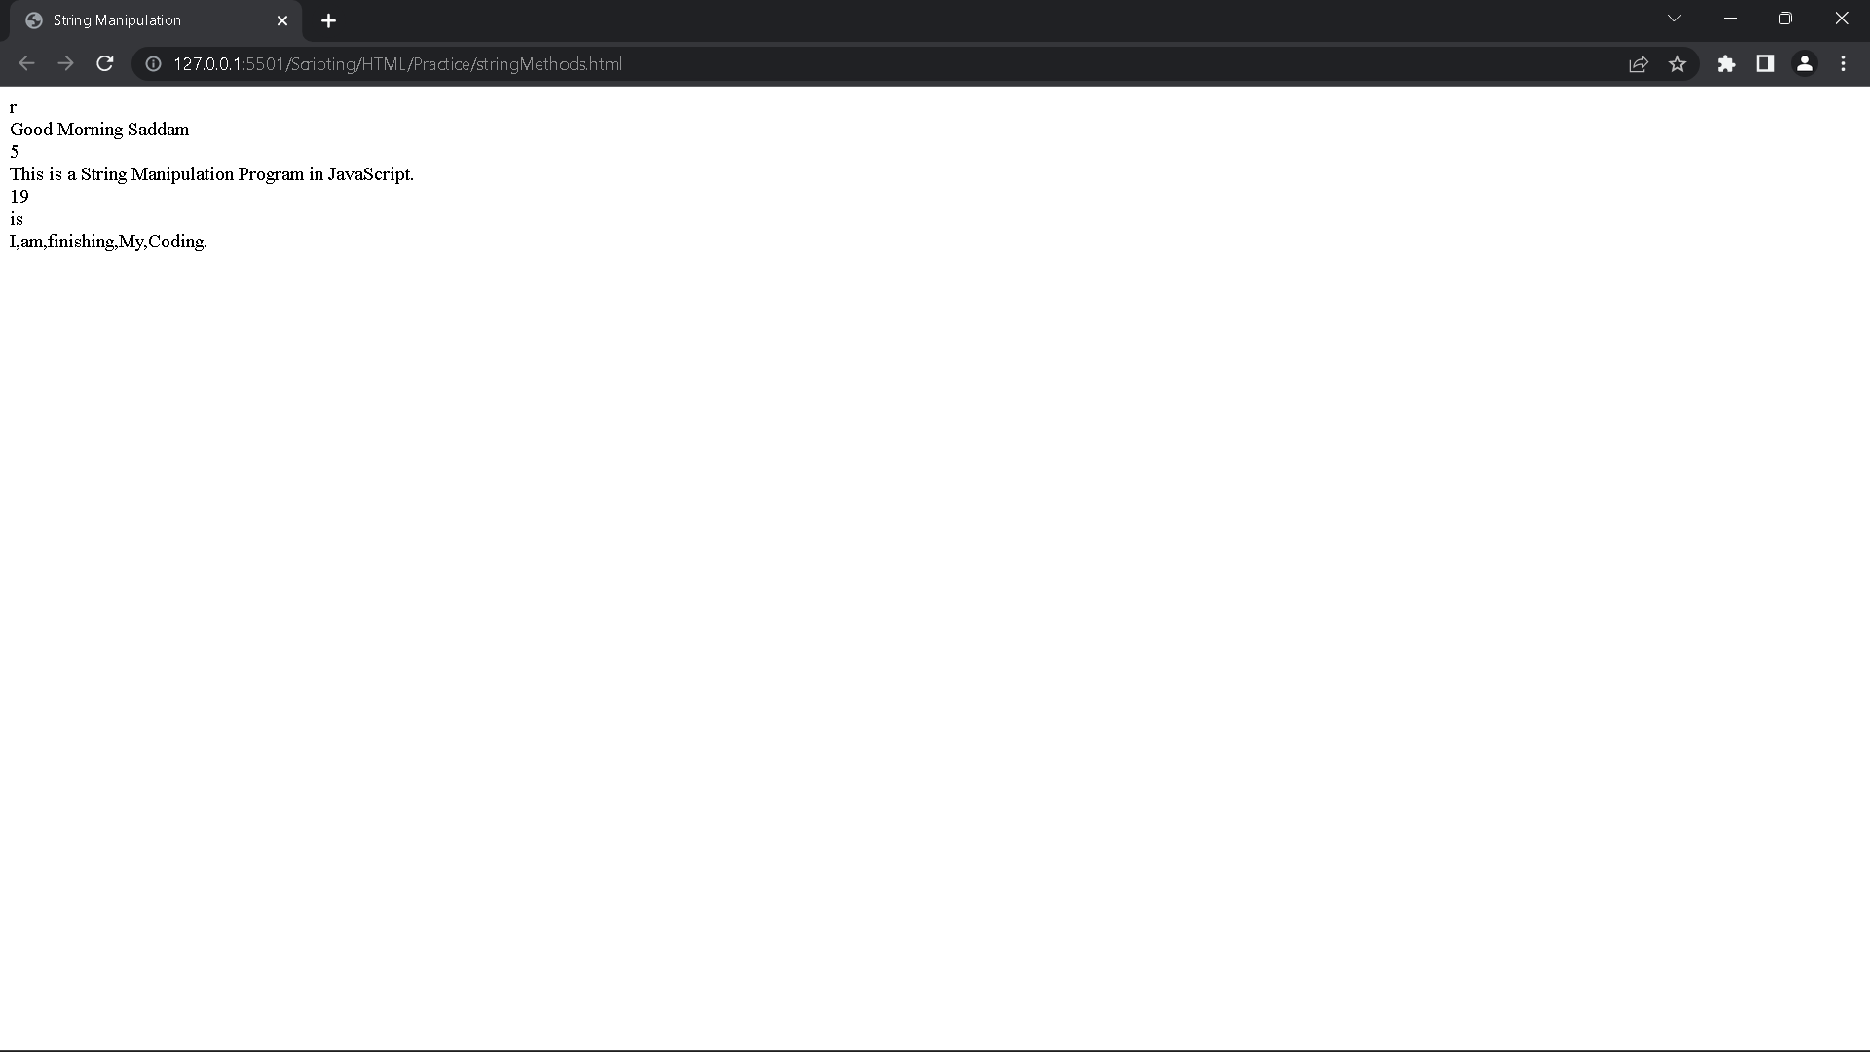

**RESULT: Thus, the above program for String manipulation using different String methods executed successfully.**

**9. Add a simple script using Click event**.

AIM: To write a JavaScript logic to use clickEvent function on a Login Page.

ALGORITHM:

Step 1: Open any Text Editor or IDE.

Step 2: Create an HTML file using .html extension.

Step 3: Now create a form with three input tags of type text, password and a button respectively.

Step 4: Create a script tag within the HTML file and match the conditions.

Step 5: Now show the alert message when the user logins.

Step 6: Close all the tags and save the file.

Step 7: Run the HTML file using Live Server Extension (in VS Code only).

**PROGRAM:**

<!DOCTYPE *html*>

<html *lang*="en">

<head>

<meta *charset*="UTF-8">

<meta *http-equiv*="X-UA-Compatible" *content*="IE=edge">

<meta *name*="viewport" *content*="width=device-width, initial-scale=1.0">

<title>Click Event in JavaScript</title>

</head>

<body>

<h2>Login Form</h2>

<form *action*="form">

<input *type*="text" *id*="user" *placeholder*="username"> <br> <br>

<input *type*="password" *id*="pswrd" *placeholder*="password"> <br> <br>

<input *type*="button" *value*="Submit" *onclick*="clickHandler()"> <br> <br>

</form>

</body>

<script>

***let*** username **=** document.getElementById("user");

***let*** password **=** document.getElementById("pswrd");

***function*** clickHandler() {

*if* (username.value **==** "sadddam" **&&** password.value **==** "748999") {

alert("Login Successfully!");

} *else* {

alert("Please enter correct details...");

}

}

</script>

</html>

**OUTPUT:**

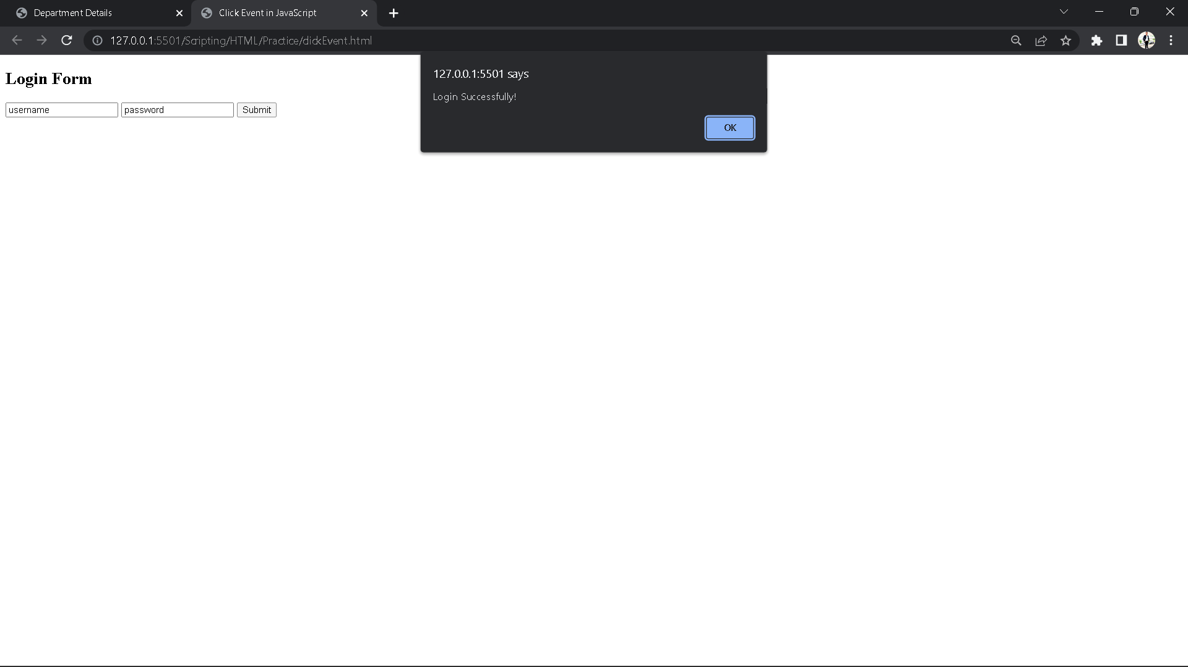

**RESULT:** Thus, The above Program for clickEvent is executed Successfully.

**10. Create Employee details using schemas.**

**AIM:** To write XML Schema to Create and Display an Employee Details.

**ALGORITHM:**

**Step 1:** Open Notepad++ and start writing XML and Schema code.

**Step 2:** Write an XML file and save it using .xml entension.

**Step 3:** Write an XML Schema file and save it using .xsd extension.

**Step 4:** In XML file, create elements like Employee Details.

**Step 5:** In XSD file, fill the details of the Employee Details.

**Step 6:** Run the .xml file using plugins>XML Tools>Validate now.

**Step 7:** If there’s no error then your program is Validated.

**PROGRAM:**

**Emp.xml:**

<?xml version="1.0" encoding="UTF-8"?>

<EmployeeDetails xmlns:xsi="http://www.w3.org/2001/XMLSchema-instance" xsi:noNamespaceSchemaLocation="emp.xsd">

<Employee>

<ID>001</ID>

<Name>Tabish</Name>

<Dept>IT</Dept>

<Designation>Manager</Designation>

</Employee>

<Employee>

<ID>002</ID>

<Name>Shahid Afridi</Name>

<Dept>IT</Dept>

<Designation>Java Developer</Designation>

</Employee>

<Employee>

<ID>003</ID>

<Name>Rituranjan</Name>

<Dept>JAVA Company</Dept>

<Designation>Ultimate Java Developer - Teacher of Java Developer</Designation>

</Employee>

</EmployeeDetails>

**emp.xsd:**

<?xml version="1.0" encoding="UTF-8"?>

<xs:schema xmlns:xs="http://www.w3.org/2001/XMLSchema">

<xs:element name="EmployeeDetails">

<xs:complexType>

<xs:sequence>

<xs:element name="Employee" maxOccurs="unbounded">

<xs:complexType>

<xs:sequence>

<xs:element name="ID" type="xs:string" />

<xs:element name="Name" type="xs:string" />

<xs:element name="Dept" type="xs:string" />

<xs:element name="Designation" type="xs:string" />

</xs:sequence>

</xs:complexType>

</xs:element>

</xs:sequence>

</xs:complexType>

</xs:element>

</xs:schema>

**OUTPUT:**

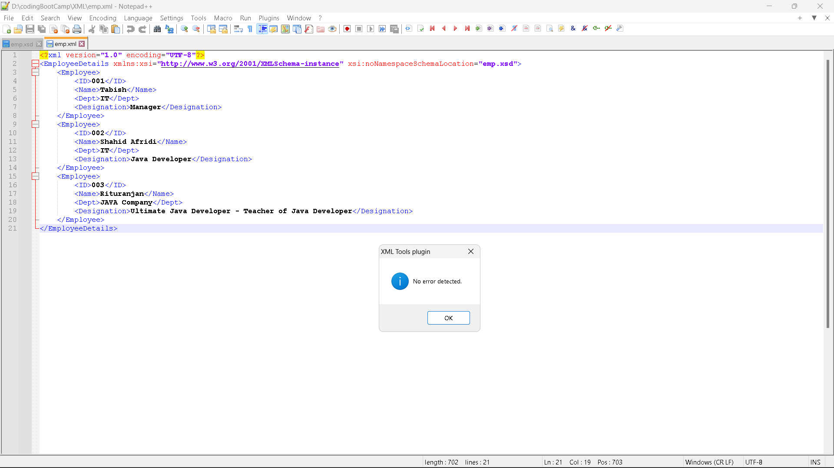

**RESULT:** Thus, The above program for getting employee details using schema is executed successfully.

**11. Create our department details using CSS.**

**AIM:** To write an HTML and CSS Program to Display our Computer Science Department Details.

**ALGORITHM:**

**Step 1:** Open any Text Editor or IDE.

**Step 2:** Create an HTML file using .html extension.

**Step 3:** In that HTML file, create two div classes and a table for storing Staffs Details.

**Step 4:** Now design the HTML file using your favourite CSS styles.

**Step 5:** Link the CSS file to your HTML file and save both files.

**Step 6:** Run the HTML file using Live Server Extension (in VS Code only).

**PROGRAM:**

**index.html**

<!DOCTYPE html>

<html lang="en">

<head>

<meta charset="UTF-8">

<meta http-equiv="X-UA-Compatible" content="IE=edge">

<meta name="viewport" content="width=device-width, initial-scale=1.0">

<title>Department Details</title>

</head>

<link rel="stylesheet" href="/Scripting/CSS/depDet.css">

<body>

<h1>School of Arts and Science</h1>

<h2>Department of Computer Science</h2>

<div class="courses">

<h2>Courses</h2>

<h3>UG Courses</h3>

<ul>

<li>BCA</li>

<li>B.Sc</li>

<li>B.Sc - IT</li>

</ul>

</div>

<div class="staffs">

<h2>Staffs List</h2>

<table rules="all">

<thead>

<tr>

<th>S. No</th>

<th>NAME</th>

<th>DESIGNATION</th>

</tr>

</thead>

<tbody>

<tr>

<td>1</td>

<td>Dr. S. Kavitha</td>

<td>H.O.D & Associate Professor</td>

</tr>

<tr>

<td>2</td>

<td>Mrs. K. Pushpavathi</td>

<td>Associate Professor</td>

</tr>

<tr>

<td>3</td>

<td>Dr. A. Vijaya Kumar</td>

<td>Assistant Professor(Grade - II)</td>

</tr>

<tr>

<td>4</td>

<td>Ms. S. Mahalakshmi</td>

<td>Assistant Professor</td>

</tr>

<tr>

<td>5</td>

<td>G. Ramasubramaniam</td>

<td>Associate Professor</td>

</tr>

<tr>

<td>6</td>

<td>Dr. B. Srinivasan</td>

<td>Associate Professor</td>

</tr>

<tr>

<td>7</td>

<td>Senthil Kumar</td>

<td>Assistant Professor</td>

</tr>

<tr>

<td>8</td>

<td>Dr. N. Sushitha</td>

<td>Associate Professor</td>

</tr>

<tr>

<td>9</td>

<td>Ms. D. Gomathi</td>

<td>Lab Assistant</td>

</tr>

</tbody>

</table>

</div>

</body>

</html>

**depDet.css**

body {

background: linear-gradient(45deg, rgb(26, 79, 27), rgb(126, 46, 46), rgb(36, 89, 36));

color: burlywood;

}

h1,

h2 {

text-align: center;

text-decoration: underline;

}

.courses,

.staffs {

border: 2px solid black;

padding: 10px 30px;

margin: 20px 3px;

}

table {

border: 2px solid black;

}

td,

th {

padding: 10px;

}

**OUTPUT:**

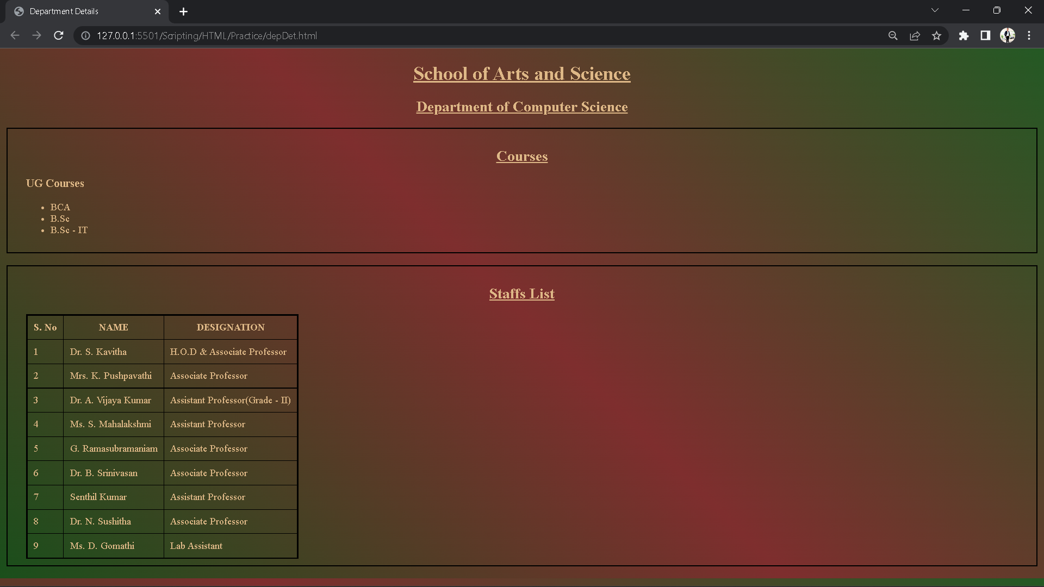

**RESULT:** Thus, the above program for Displaying the Department Details created and executed Successfully.

**12.**  **Create Payroll System using XSL.**

**AIM:** To write an XML Program to validate the Employee Payrolls

**ALGORITHM:**

**Step 1:** Open any Text Editor or IDE.

**Step 2:** Create an XML and XSL file using .xml and .xsl extension respectively.

**Step 3:** Create the Employee details in the XML file.

**Step 4:** In the XML file create a table to store all the Employee details.

**Step 5:** Close all the tags and save both the files in the same folder.

**Step 6:** Run the XSL file to see the Output.

**PROGRAM:**

**Employee.xsl**

**<?xml** version = "1.0" encoding = "UTF-8"**?>**

**<xsl:stylesheet** version = "1.0"

xmlns:xsl = "http://www.w3.org/1999/XSL/Transform"**>**

**<xsl:template** match = "/"**>**

**<html>**

**<body>**

**<h2>**Employee**</h2>**

**<table** border = "1"**>**

**<tr** bgcolor = "#9acd32"**>**

**<th>**ID**</th>**

**<th>**First Name**</th>**

**<th>**Last Name**</th>**

**<th>**Nick Name**</th>**

**<th>**Salary**</th>**

**</tr>**

**<xsl:for-each** select="class/employee"**>**

**<tr>**

**<td>**

**<xsl:value-of** select = "@id"**/>**

**</td>**

**<td><xsl:value-of** select = "firstname"**/></td>**

**<td><xsl:value-of** select = "lastname"**/></td>**

**<td><xsl:value-of** select = "nickname"**/></td>**

**<td><xsl:value-of** select = "salary"**/></td>**

**</tr>**

**</xsl:for-each>**

**</table>**

**</body>**

**</html>**

**</xsl:template>**

**</xsl:stylesheet>**

**"employee.xml"**

**<?xml** version = "1.0"**?>**

**<?xml-stylesheet** type = "text/xsl" href = "employee.xsl"**?>**

**<class>**

**<employee** id = "001"**>**

**<firstname>**Aryan**</firstname>**

**<lastname>**Gupta**</lastname>**

**<nickname>**Raju**</nickname>**

**<salary>**30000**</salary>**

**</employee>**

**<employee** id = "024"**>**

**<firstname>**Sara**</firstname>**

**<lastname>**Khan**</lastname>**

**<nickname>**Zoya**</nickname>**

**<salary>**25000**</salary>**

**</employee>**

**<employee** id = "056"**>**

**<firstname>**Peter**</firstname>**

**<lastname>**Symon**</lastname>**

**<nickname>**John**</nickname>**

**<salary>**10000**</salary>**

**</employee>**

**</class>**

**OUTPUT:**

**Employee**

|  |  |  |  |  |
| --- | --- | --- | --- | --- |
| **ID** | **First Name** | **Last Name** | **Nick Name** | **Salary** |
| 001 | Aryan | Gupta | Raju | 30000 |
| 024 | Sara | Khan | Zoya | 25000 |
| 056 | Peter | Symon | John | 10000 |

**RESULT:** Thus, The above XML Program for validating the Employees Payroll is executed Successfully.

**13.**  **Changing image using mouseover event.**

**AIM:** To write a JavaScript Logic to Change the Image using onmouseover() event.

**ALGORITHM:**  
  
**Step 1:** Open any Text Editor or IDE.

**Step 2:** Create an HTML file by saving it using .html extension.

**Step 3:** Import an <img> with attribute an mouseover event.

**Step 4:** Start the script tag and create a function for mouseover event.

**Step 5:** Close all the tags and save the file.

**Step 6:** Run the file using Live Server Extension (in VS Code only).

**PROGRAM:**

**index.html**

<!DOCTYPE html>

<html lang="en">

<head>

<meta charset="UTF-8">

<meta http-equiv="X-UA-Compatible" content="IE=edge">

<meta name="viewport" content="width=device-width, initial-scale=1.0">

<title>Mouse Over Event in JavaScript</title>

</head>

<body>

<img src="human.jpeg" alt="" id="image" onmouseover="mouseOverHandler()" width="250px" height="250px">

</body>

<script src="/Scripting/JavaScript/mouseOv.js"></script>

</html>

**mouseOv.js**

function mouseOverHandler() {

let Image = document.getElementById("image");

if (Image.src.match("human")) {

Image.src = "macaque.jpeg";

} else {

Image.src = "human.jpeg";

}

}

**OUTPUT:**

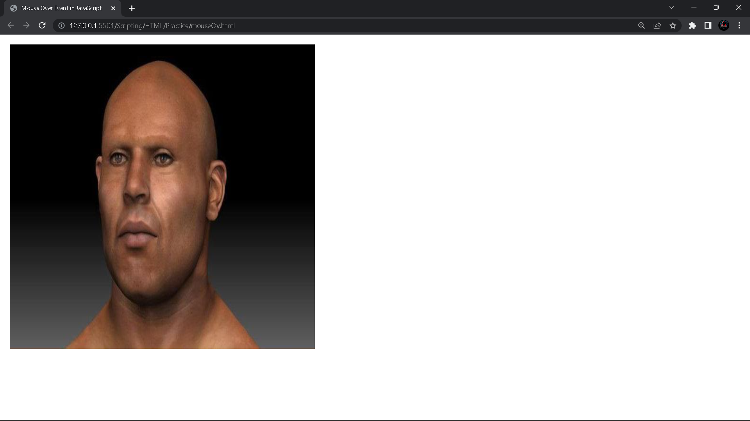

**RESULT:** Thus, The above program for mouseover event is created and executed successfully.

**14. Create a website for a Newspaper.**

**AIM:** To create a website for a newspaper using HTML and CSS.

**ALGORITHM:**

**Step 1:** Open any Text Editor or IDE.

**Step 2:** Create an HTML file using .html extension.

**Step 3:** Create <div> containers like a tree structure and store the news in it.

**Step 4:** Divide them in multiple containers to display various different news.

**Step 5:** Give Styling as per your needs and close all the tags.

**Step 6:** Run the HTML file using Live Server Extension.

**PROGRAM:**

<!DOCTYPE html>

<html lang="en">

<head>

<meta charset="UTF-8">

<meta http-equiv="X-UA-Compatible" content="IE=edge">

<meta name="viewport" content="width=device-width, initial-scale=1.0">

<title>iNews - All your news are here!</title>

</head>

<body>

<div class="container">

<h1>Welcome to iNews</h1>

<div class="row">

<div class="content">

<h2>News about Kerala</h2>

<img src="https://live.staticflickr.com/5129/5297367230_6591ddf51f_b.jpg" / alt="">

<p>Lorem, ipsum dolor sit amet consectetur adipisicing elit. Possimus perspiciatis quas dicta minima quod

provident aliquid. Lorem ipsum, dolor sit amet consectetur adipisicing elit. Aspernatur atque possimus modi

consequuntur molestiae huwei. <a href="https://timesofindia.indiatimes.com/india/kerala">Read more...</a></p>

</div>

<div class="content">

<h2>News about Tamilnadu</h2>

<img src="https://live.staticflickr.com/5129/5297367230_6591ddf51f_b.jpg" / alt="">

<p>Lorem ipsum dolor sit amet consectetur adipisicing elit. Perferendis excepturi natus nostrum numquam odio

asperiores dolorem aliquid porro. Lorem ipsum dolor sit amet consectetur adipisicing elit. Omnis asperiores

modi minus? <a href="https://timesofindia.indiatimes.com/india/tamil-nadu">Read More.......</a></p>

</div>

<div class="content">

<h2>News about Patna</h2>

<img src="https://live.staticflickr.com/5129/5297367230_6591ddf51f_b.jpg" / alt="">

<p>Lorem ipsum dolor sit amet consectetur adipisicing elit. Ipsa, ullam! Rerum ratione, quasi corporis iure

repellat laudantium voluptates eos doloremque perferendis consequatur dolores magnam soluta quia incidunt

pariatur assumenda autem magni <a href="https://timesofindia.indiatimes.com/city/patna">Read more...</a></p>

</div>

</div>

<div class="row">

<div class="content">

<h2>News about Bihar</h2>

<img src="https://live.staticflickr.com/5129/5297367230_6591ddf51f_b.jpg" / alt="">

<p>Lorem ipsum dolor sit amet consectetur adipisicing elit. Vitae corporis tenetur, laudantium similique nobis

vero. Optio explicabo aliquid cum quas nostrum vel nam. Lorem ipsum dolor sit amet consectetur. <a

href="https://timesofindia.indiatimes.com/india/bihar">Read More......</a></p>

</div>

<div class="content">

<h2><u>Wildlife News!</u></h2>

<img src="https://live.staticflickr.com/5129/5297367230_6591ddf51f_b.jpg" / alt="">

<p>Lorem ipsum dolor sit amet consectetur, adipisicing elit. Cum, veniam optio voluptates voluptatibus <a

href="https://www.livescience.com/topics/wildlife">Read More......</a>

<p>

</div>

<div class="content">

<h2><u>Natural Disaster News!</u></h2>

<img src="https://live.staticflickr.com/5129/5297367230_6591ddf51f_b.jpg" / alt="">

<p>Lorem ipsum dolor, sit amet consectetur adipisicing elit. Ratione obcaecati quam officia explicabo. Quam

corrupti nemo et, nesciunt delectus, expedita soluta possimu ewuis yuaS Kojeas modi itaque quo nisi nam vitae?

<a href="https://www.foxnews.com/category/science/planet-earth/natural-disasters">Read More......</a>

</p>

</div>

</div>

</div>

<style>

* {

margin: 0;

padding: 0;

box-sizing: border-box;

}

body,

.container,

.row {

display: flex;

align-items: center;

justify-content: center;

}

body {

width: 100%;

height: 100vh;

text-align: center;

}

h1 {

color: red;

border: 2px solid black;

border-radius: 9px;

display: block;

width: 100%;

}

.container {

width: 90%;

flex-direction: column;

}

.row {

border: 2px solid rgb(6, 84, 107);

width: 100%;

margin: 10px;

}

.content {

padding: 0 5px;

margin: 5px;

border: 2px solid rgb(14, 3, 71);

width: 33%;

height: 280px;

overflow: scroll;

overflow-x: hidden;

}

.content::-webkit-scrollbar{

display: none;

}

img {

align-items: center;

width: 90%;

height: 55%;

}

</style>

</html>

**OUTPUT:**

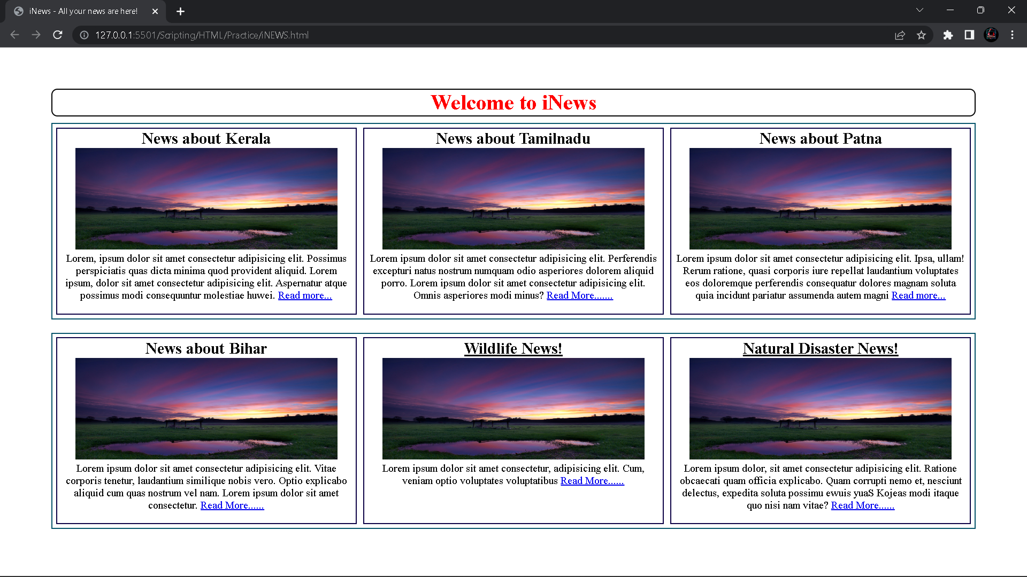

**RESULT:** Thus, the above program for a newspaper is created and executed successfully.

**15. Design and apply your application form for course enrolment using JavaScript.**

**AIM:** To create an application form for course enrolment using JavaScript.

**ALGORITHM:**

**Step 1:** Open any Text Editor or IDE.

**Step 2:** Create different files for HTML, CSS and JavaScript.

**Step 3:** Create an Application form using HTML.

**Step 4:** Give Style and Design to that HTML file using CSS.

**Step 5:** Write the functionality for the HTML code using JavaScript.

**Step 6:** Close all the tags and connect all the files to the HTML file.

**Step 7:** Run the HTML file using Live Server Extension (in VS Code only).

**PROGRAM:**

**index.html:**

<html>

<head>

<meta charset="utf-8">

<title>Course Enrolment Form</title>

<link rel="stylesheet" href="style.css">

</head>

<body>

<div class="container">

<div class="header">

<img src="https://www.avsas.ac.in/logo1.png" height="100" width="300">

<br> AV Campus, Bharatiyar Block,<br>Paiyanoor OMR, Chennai 603104 - Tamil

Nadu<br>www.avsas.ac.in

</div>

<div class="upper">

<h2>Application Form</h2><br>

<label for="date">Date :</label>

<input type="text" id="date"><br>

<label for="rollno">Roll No :</label>

<input type="text" id="rollno">

</div>

<div class="form">

<label for="name">Name :</label>

<input type="text" id="name"><br>

<label for="dob">Date of Birth :</label>

<input type="text" id="dob"><br>

Male <input type="radio" name="Gender">

Female <input type="radio" name="Gender">

Others <input type="radio" name="Gender"><br>

<label for="nation">Nationality :</label>

<input type="text" id="nation"><br>

<label for="idproof">Id Proof :</label>

<input type="file" id="idproof"><br>

<label for="educ">Highest Education Qualification :</label>

<input type="file" id="educ"><br>

<label for="qual">Please specifics any previous study :</label>

<input type="text" id="qual"><br>

</div>

<hr>

<h3> ------------Course enrolled for----------------</h3>

<div class="course">

Telly Course<input type="checkbox">

MBA <input type="checkbox">

BCA<input type="checkbox">

B.Sc CS<input type="checkbox">

BBA<input type="checkbox">

</div>

<hr>

<div class="contact">

<h3> Contact Details:</h3>

<label for="phone">Hone Phone :</label>

<input type="text" id="phone"><br>

<label for="email">Email :</label>

<input type="email" id="email"><br>

<label for="gName"> Parents/ Guardian :</label>

<input type="text" id="gName"><br>

<label for="rel"> Relation :</label>

<input type="text" id="rel"><br>

<label for="phone"> Phone No :</label>

<input type="text" id="phone"><br>

<label for="add"> Address :</label>

<input type="text" id="add">

</div>

<hr>

<div class="decl">

<h3>Declaration:</h3>

<span>1. I hereby declare that all the information stated above is true .</span><br>

<span>2. I am fully aware of all the details for the course .</span>

</div>

<div class="sign">

<label for="sSign"> Signature of the Student :

<input type="file" id="sSign">

<label for="aSign"> Authorized Signature :</label>

<input type="file" id="aSign">

</div>

<hr>

<button type="submit" value="submit" onclick="clickHandler()" id="sbmt">Submit</button>

</div>

<script src="script.js"></script>

</body>

</html>

**style.css:**

* {

margin: 0;

padding: 0;

box-sizing: border-box;

}

body {

width: 100%;

font-family: 'Montserrat', sans-serif;

display: flex;

justify-content: center;

align-items: center;

font-size: 20px;

color: rgb(78, 76, 76);

}

div {

margin: 20px 10px;

}

input {

border: none;

border-bottom: 2px dotted #000;

text-decoration: dashed;

margin-bottom: 15px;

font-size: 22px;

}

input:focus {

border: none;

}

.container {

display: flex;

width: 50%;

justify-content: center;

flex-direction: column;

border: 1px solid black;

margin: 0;

}

.header,

h2,

h3 {

text-align: center;

margin: 10px 0;

}

.course {

font-weight: bold;

padding: 20px 0;

}

.course input,

input[type="radio"] {

width: 25px;

height: 25px;

margin-right: 8%;

}

input[type="file"] {

width: 23%;

}

button[type="submit"] {

padding: 10px 7px;

margin: 15px 10px;

background-color: chartreuse;

font-size: 25px;

font-weight: bold;

}

@media (max-width: 670px) {

.container {

width: 100%;

}

}

**script.js:**

function clickHandler() {

for (const input of element) {

if (input.value == "") {

alert("Fill all the field first");

return;

} else {

alert("Your application submitted succesfully");

return;

}

}

}

**OUTPUT:**

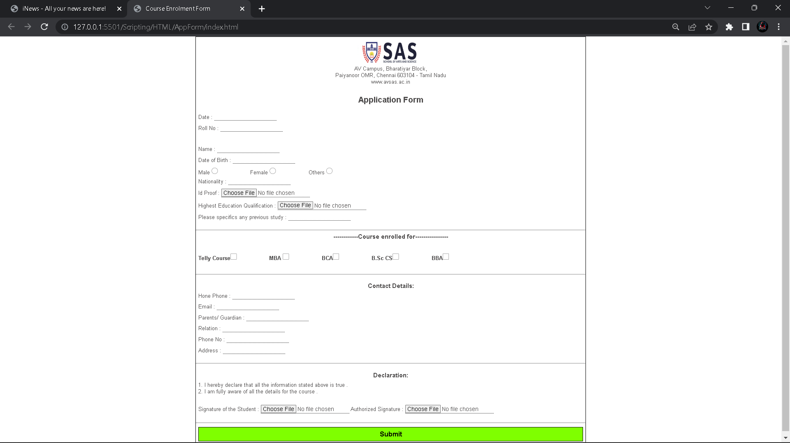

**RESULT:** Thus, The above application form for Course enrolment is created successfully.